**VS-Code Installation**

1. **Click the below link and download the corresponding software**

[**https://code.visualstudio.com/download**](https://code.visualstudio.com/download)

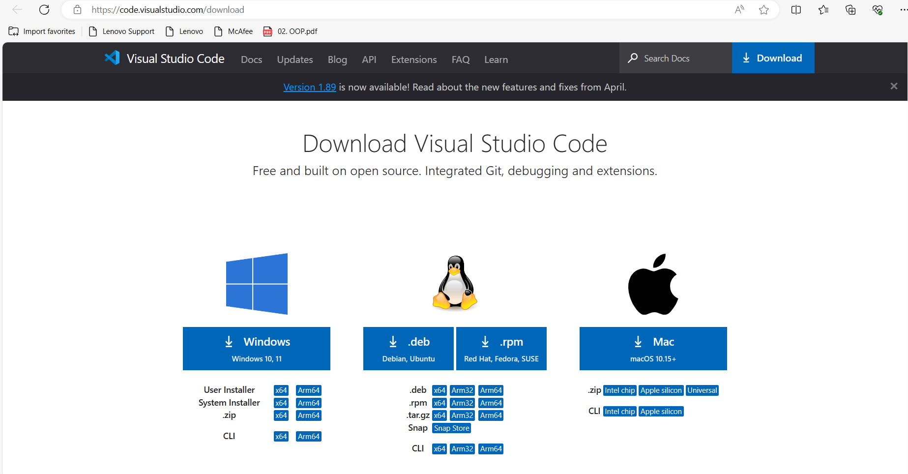

1. **Once the downloading is completed install it**

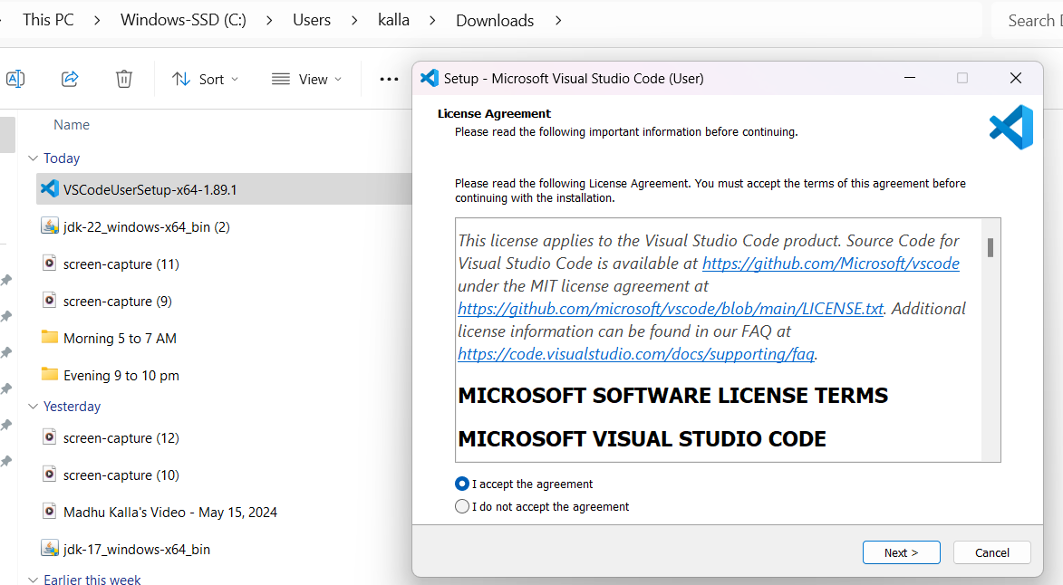

1. **select the below checkboxes**

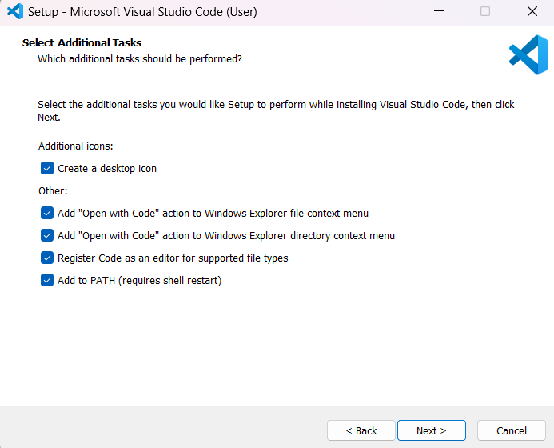

1. **installation completed**

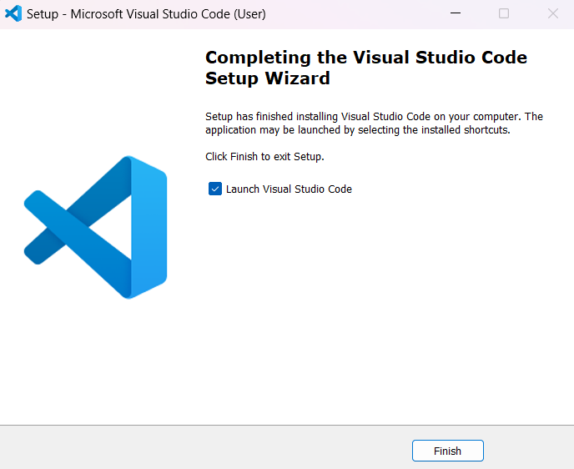

**After installation completed**

**You have to install some extensions like below**

1. **java extensions**
2. **code runner**

**Click on extensions icon**

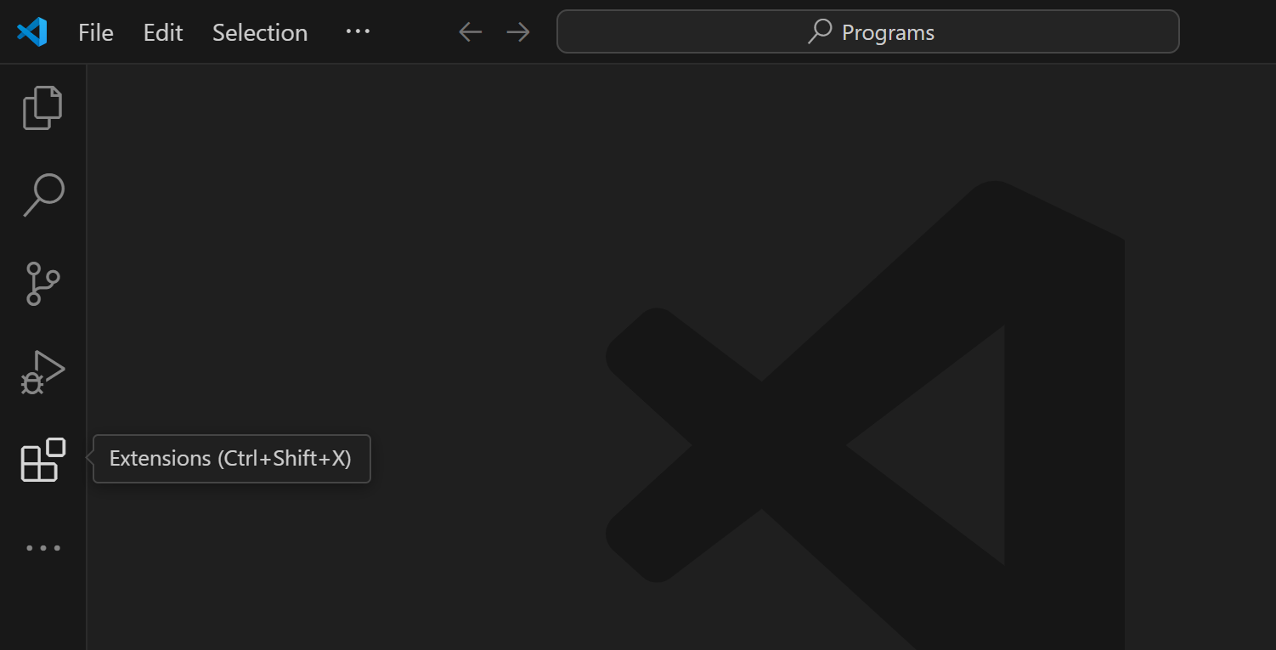

1. **search for java in extensions and install Extension pack for java**

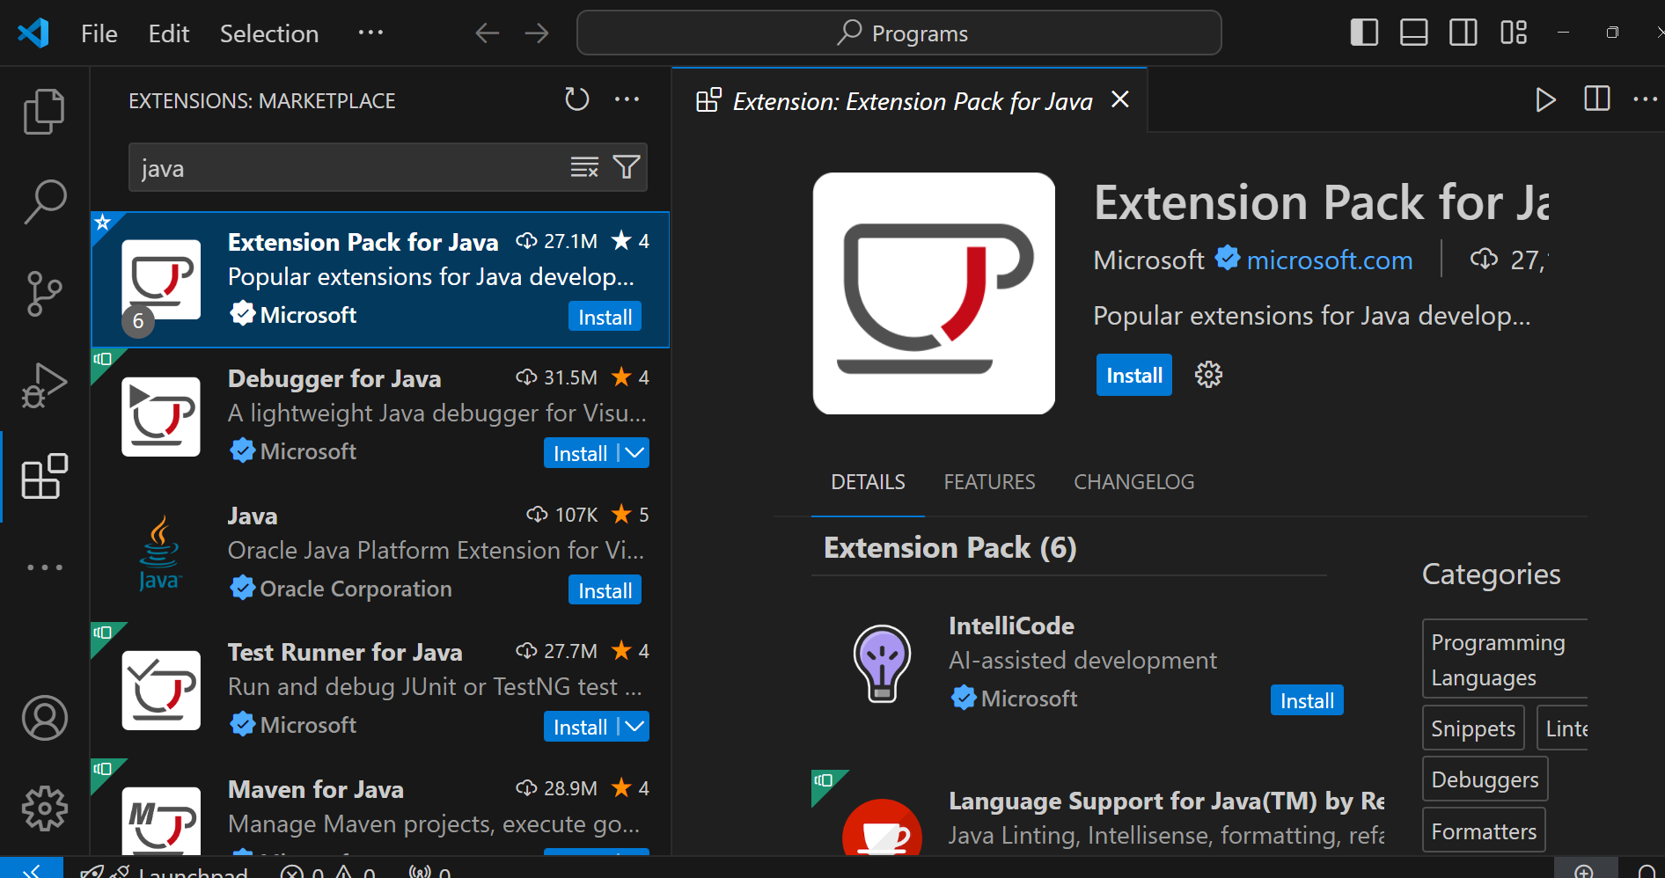

1. **install code runner**

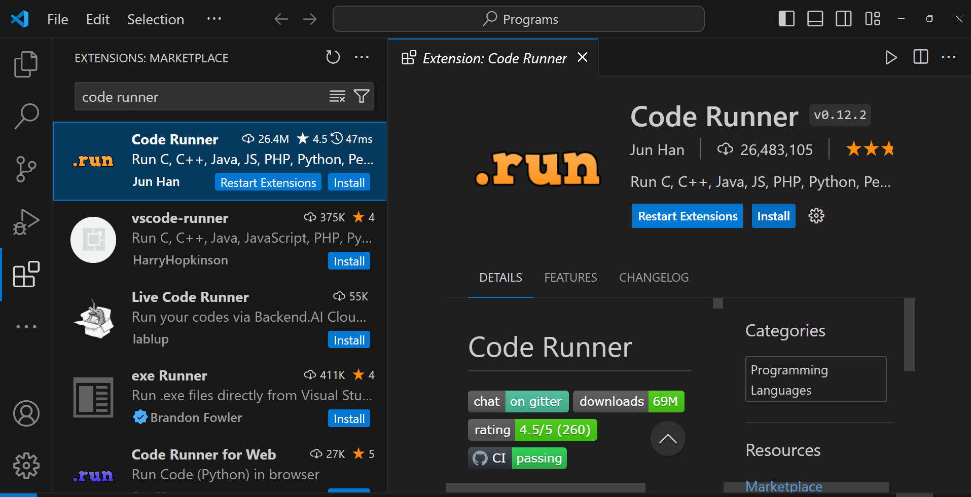

1. **click on Manage icon**

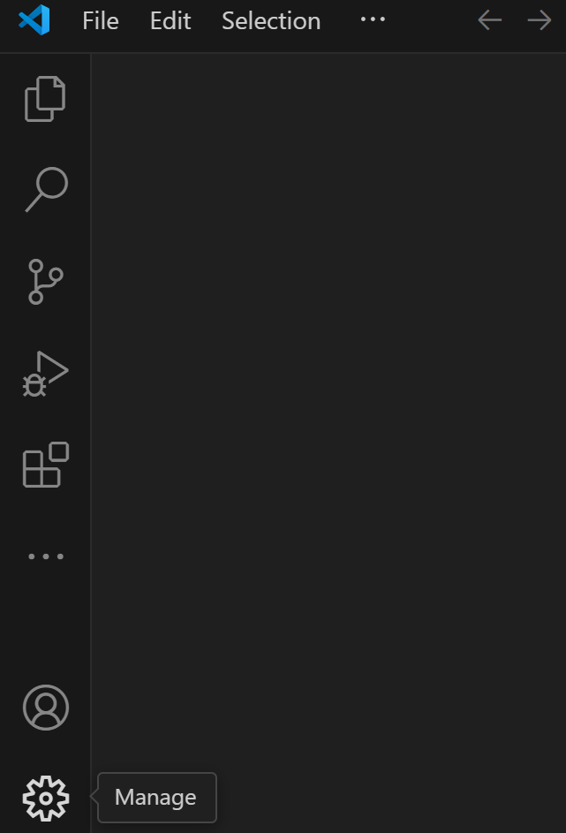

1. **click on settings**

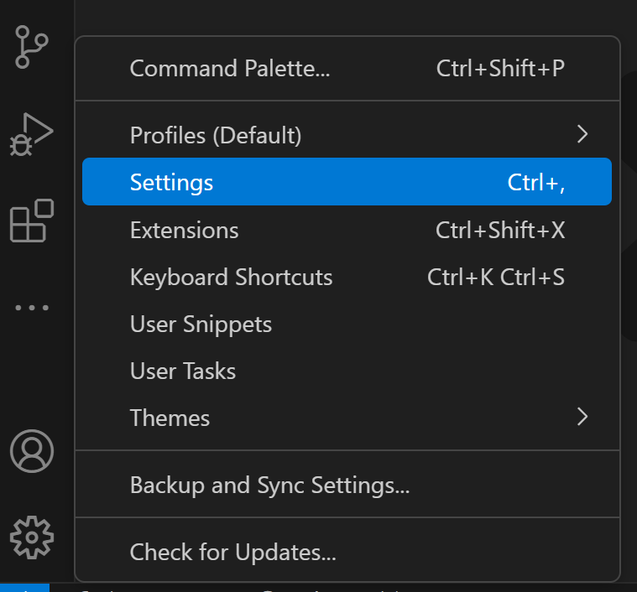

1. **A new window will be opened and in that window search for Run In Terminal**

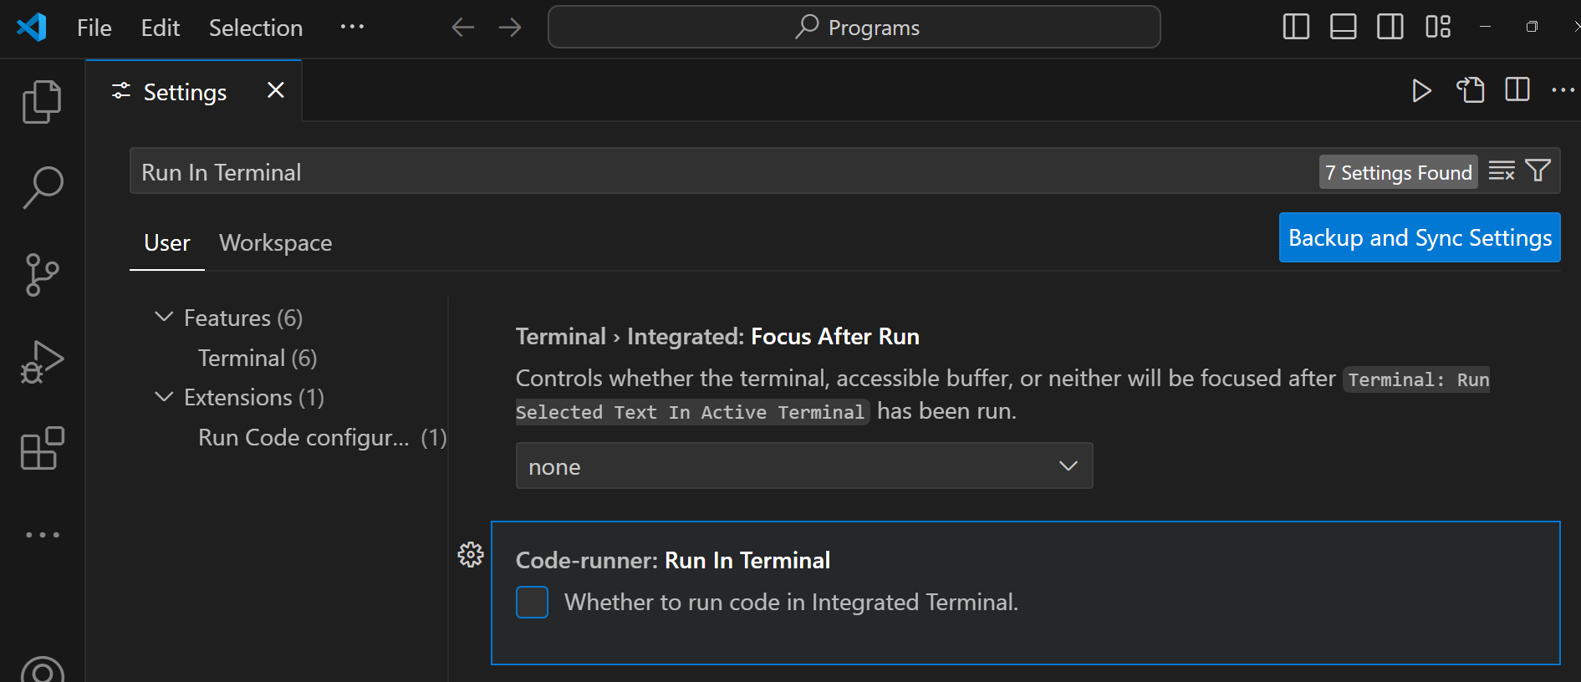

1. Check the box(Code-runner: Run In Terminal)
2. You are done(now you can write and run java programs from vs code).